**Data Analytics on Indigo Airlines’ Business Model**

**Index**

1. Description
2. Data & Problem Context
3. Plan
4. Design
5. Implementation
6. Code with Explanation
7. Output Screenshots
8. Closure
9. Bibliography

**Description**

**Project Title:** Data Analytics on Indigo Business Model  
This project aims to analyse the operational strategies and performance of Indigo Airlines using real-world aviation data. By studying air traffic patterns, sector-wise demand, and market share metrics, the goal is to gain a deeper understanding of the factors contributing to Indigo's dominance in the Indian aviation industry.

**Data & Problem Context**

**Problem Statement:**  
Indigo Airlines holds the largest market share in India’s aviation sector. To sustain and strengthen this position, it is crucial to understand the factors driving its success. This project addresses:

* Top-performing air travel sectors in India
* Sectors with increasing future demand
* Airlines likely to grow based on market share
* Impact of delays on operations
* Data-driven insights into Indigo’s new route decisions

**Purpose & Outcome:**  
To create an interactive, modular data analytics app capable of delivering visual insights into key aviation metrics. The goal is to support business decisions using data.

**Benefits:**

* Improved sector targeting
* Demand forecasting for route expansion
* Competitive benchmarking among airlines
* GUI-based visualization for enhanced user interaction

**Plan**

* Gather relevant datasets from DGCA & Kaggle
* Preprocess and clean the data
* Analyze traffic and market trends
* Build GUI for user interaction
* Generate outputs for each major insight
* Add delay pattern module for extended analysis

**Design**

**Modular Structure:**

* **DataLoader Module:** Reads and cleans raw data
* **Analysis Module:** Core analytics (sectors, trends, shares)
* **Visualization Module:** Plot diagrams via matplotlib
* **GUI Module:** User interface via Tkinter

**Data Flow Diagram (DFD)**

User

Analysis Engine

Cleaned Data

GUI Layer

Visualization

**Implementation**

**Technologies Used:**

* **Language:** Python
* **Libraries:** pandas, numpy, matplotlib, seaborn, tkinter
* **Paradigm:** Object-Oriented Programming
* **Data Sources:**
  + Directorate General of Civil Aviation (DGCA)
  + Kaggle (open-source datasets)

**Features:**

* Sector-wise traffic analysis
* Forecast model for demand growth
* Airline market share charts
* Delay analysis for punctuality insights
* Tkinter-based interactive GUI

**Code with Explanation**

**DataLoader Code:**

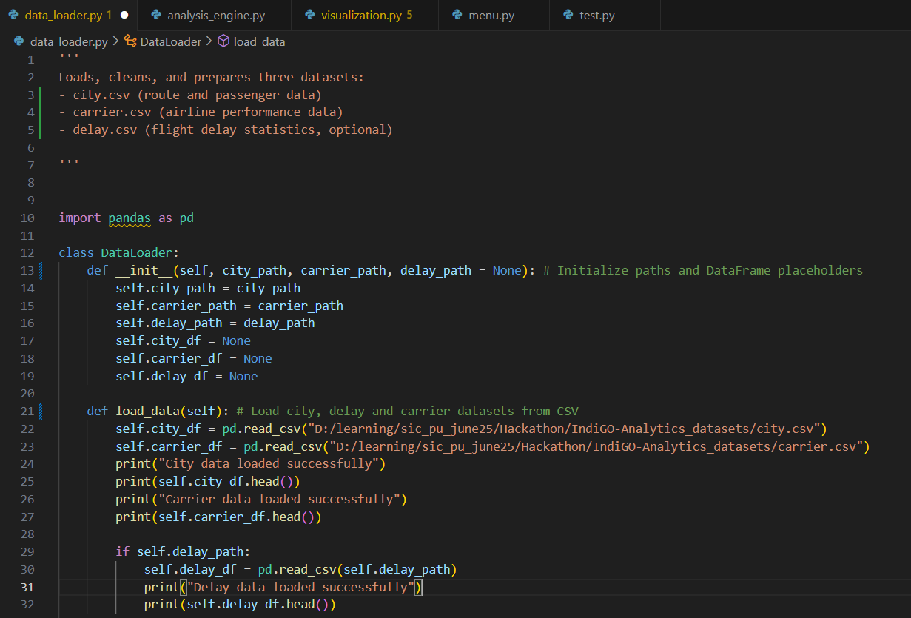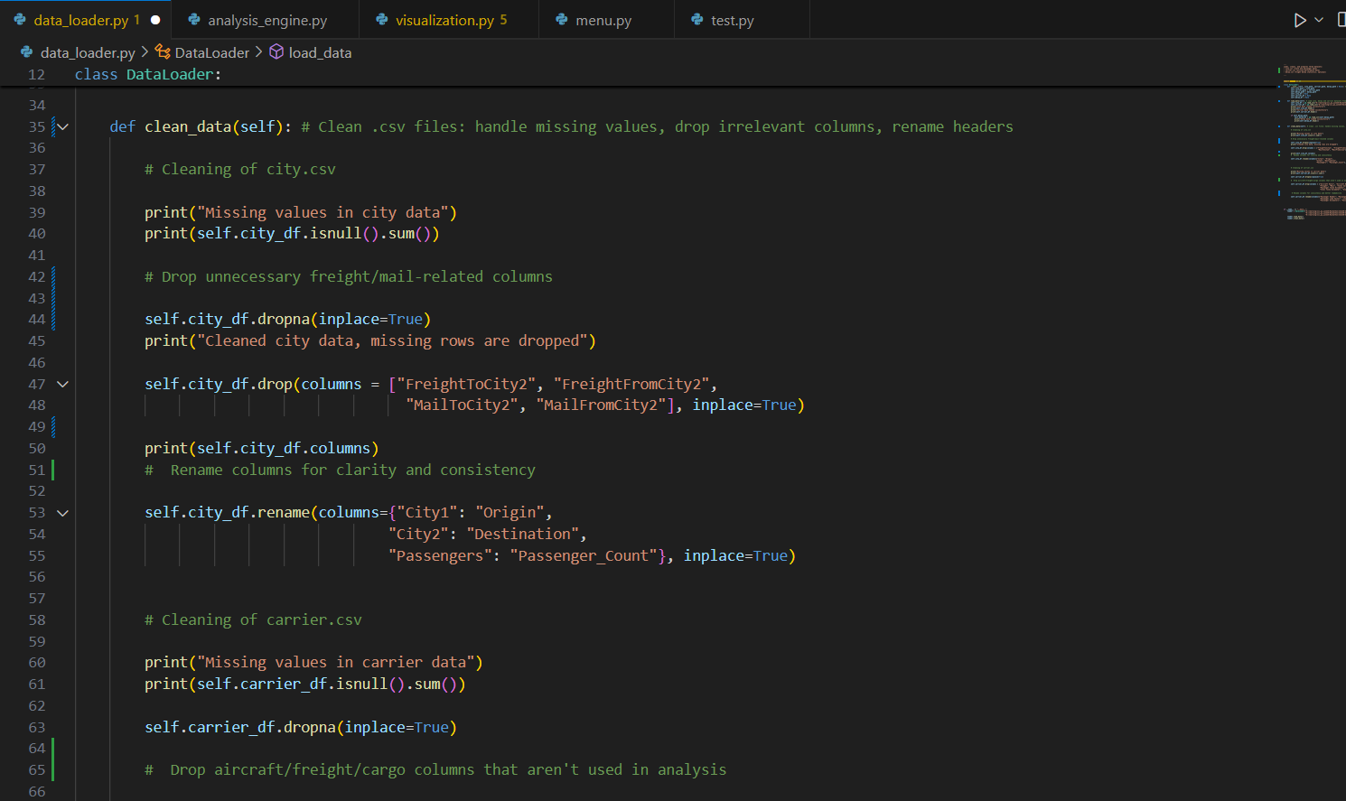

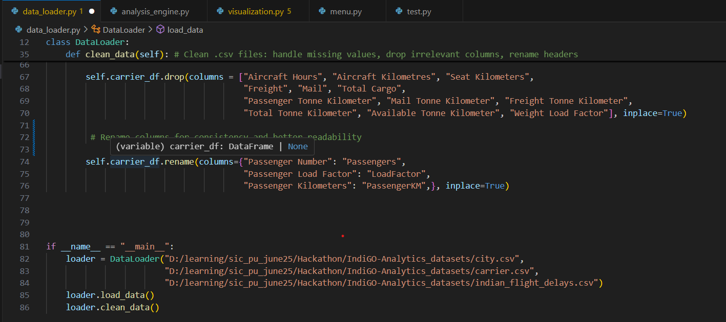

**Analysis Code:**

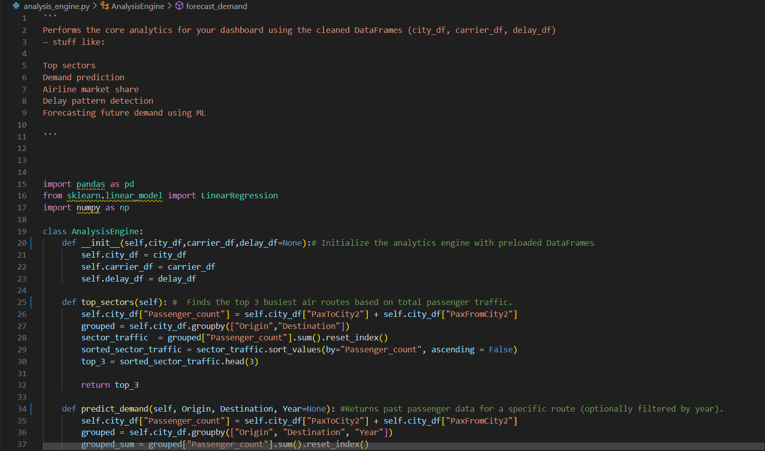

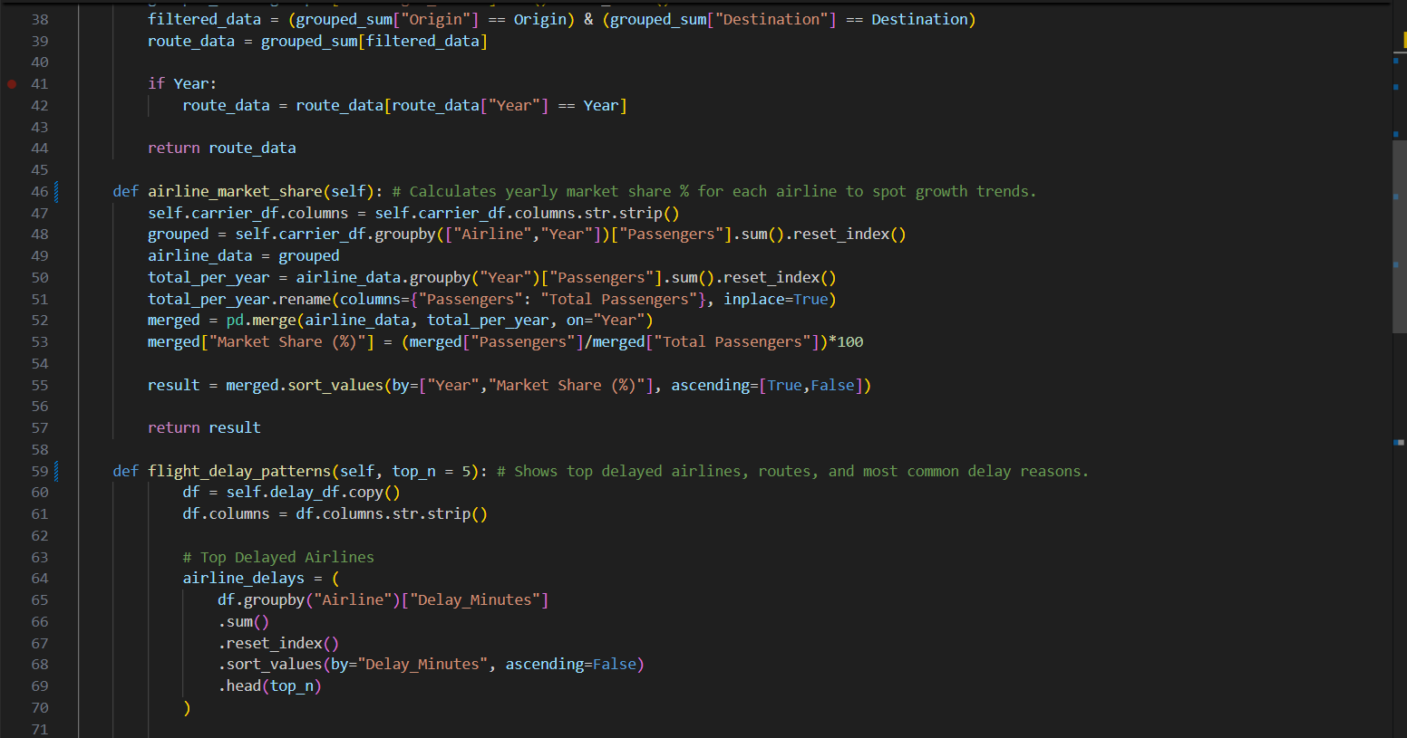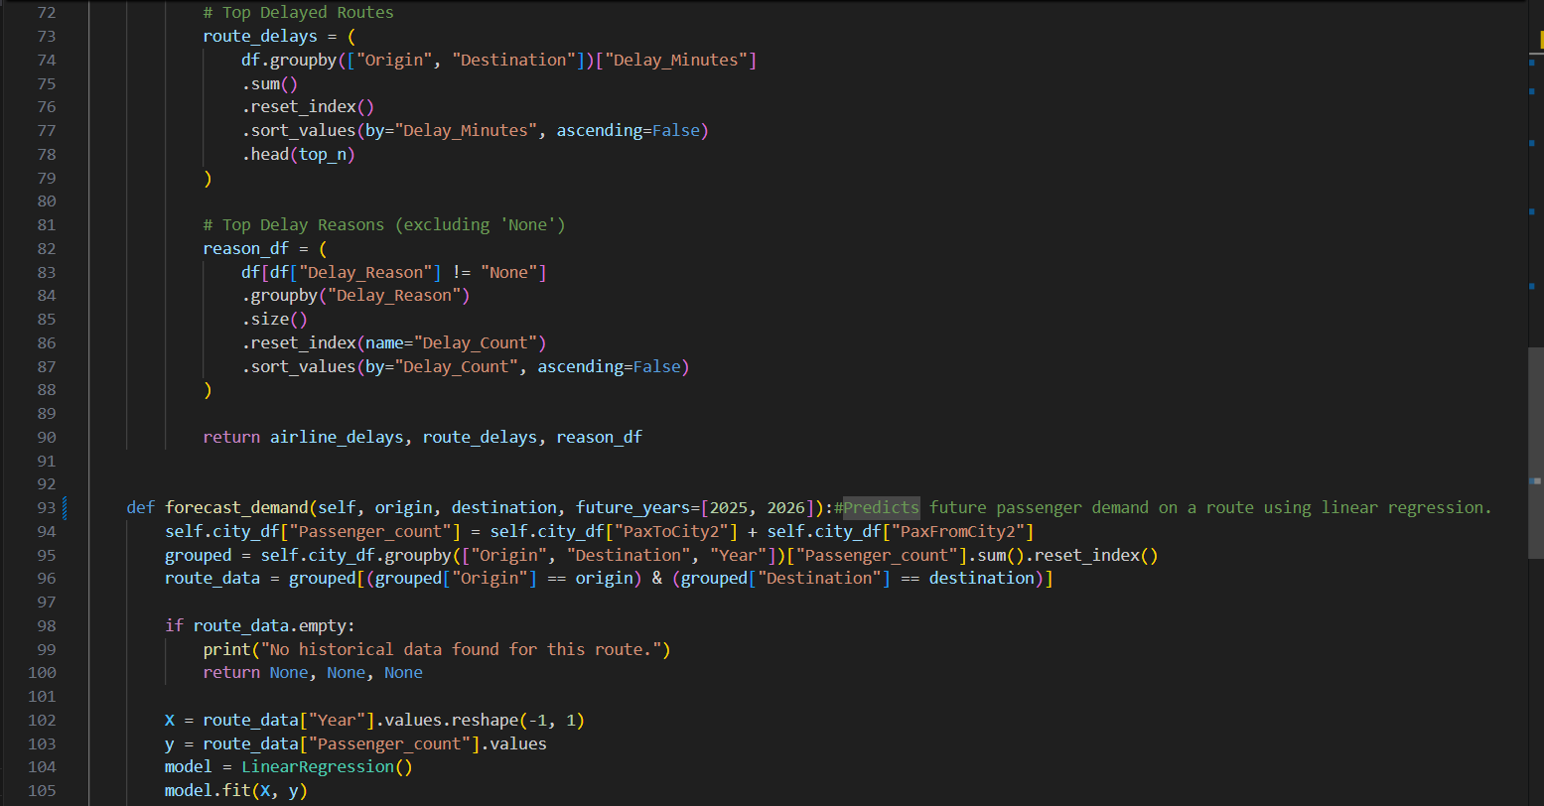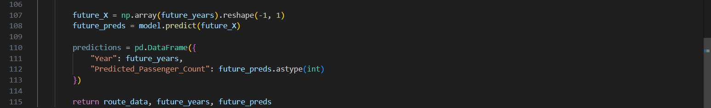

**Visualization Code:**

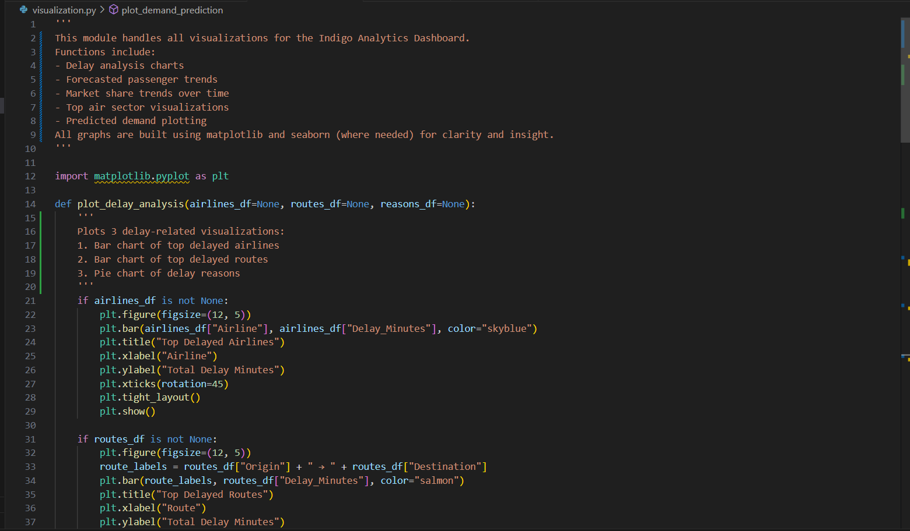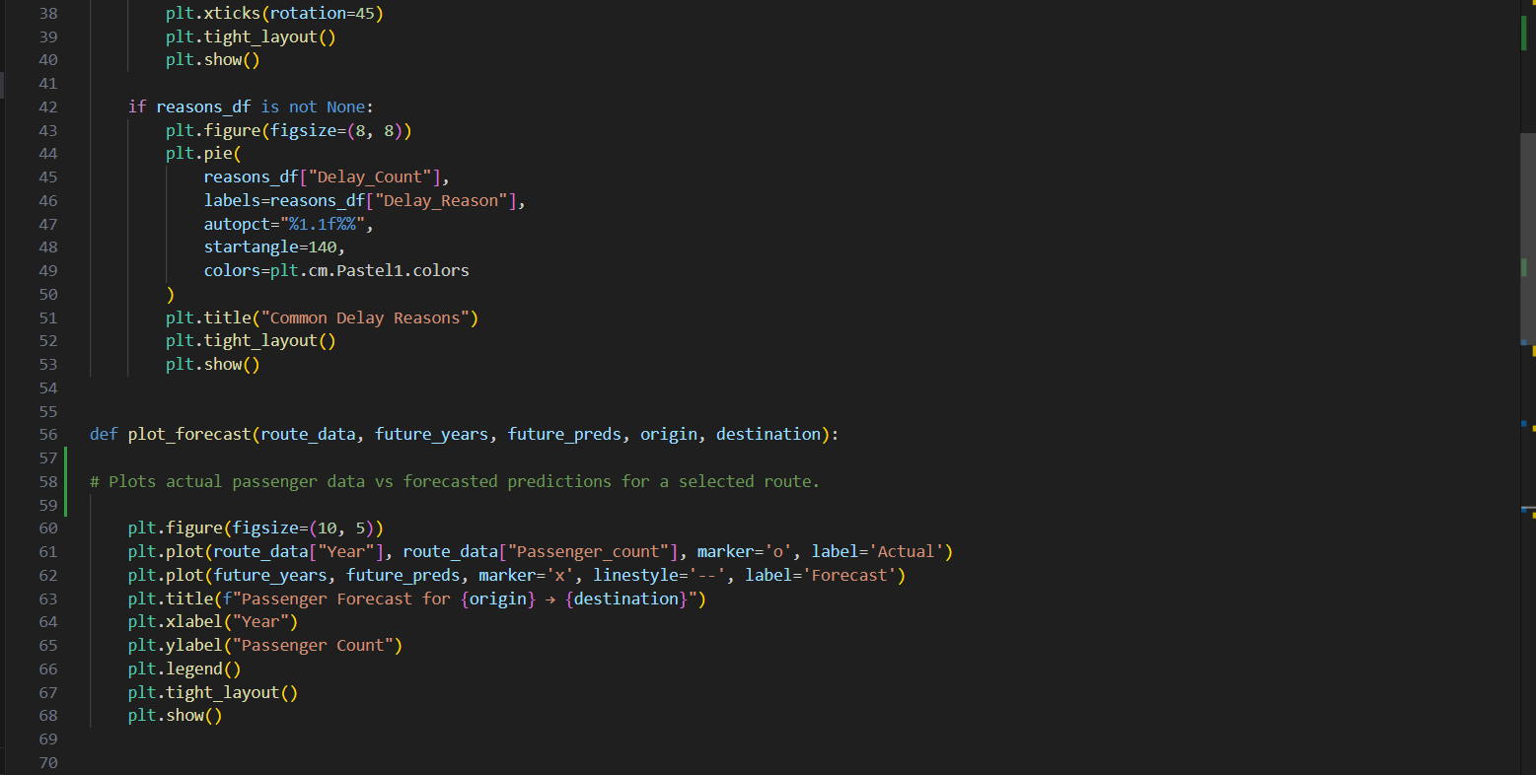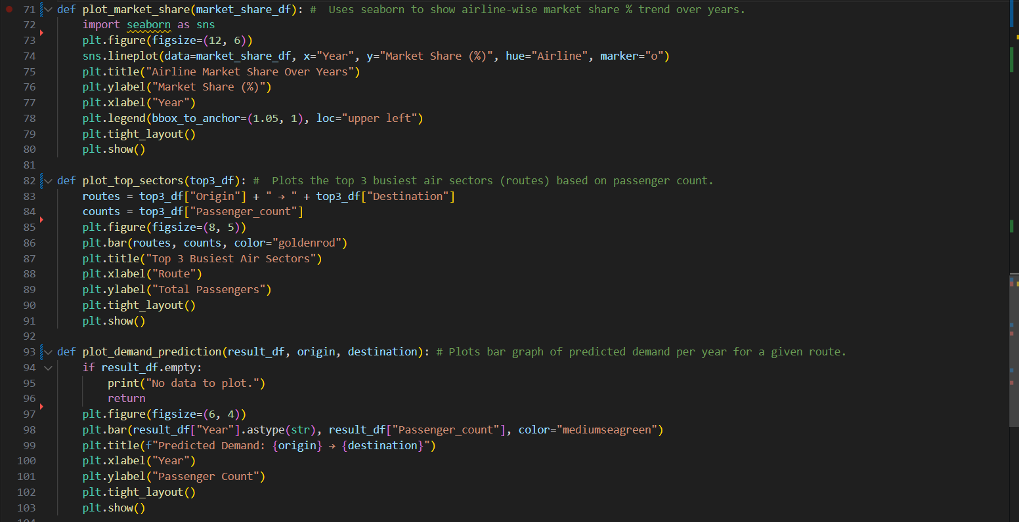

**Menu Code:**

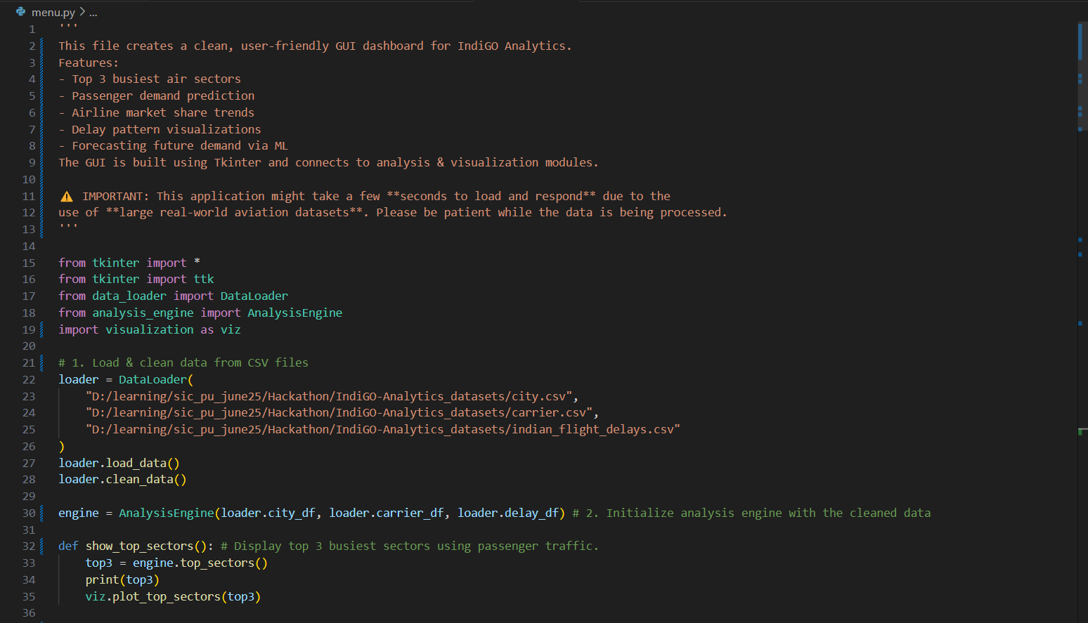

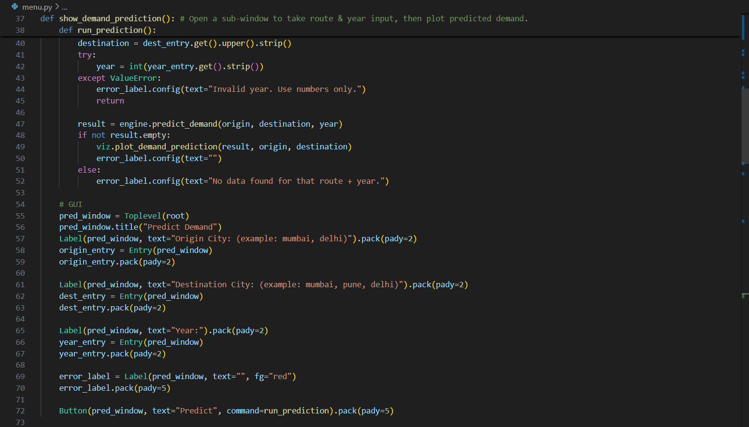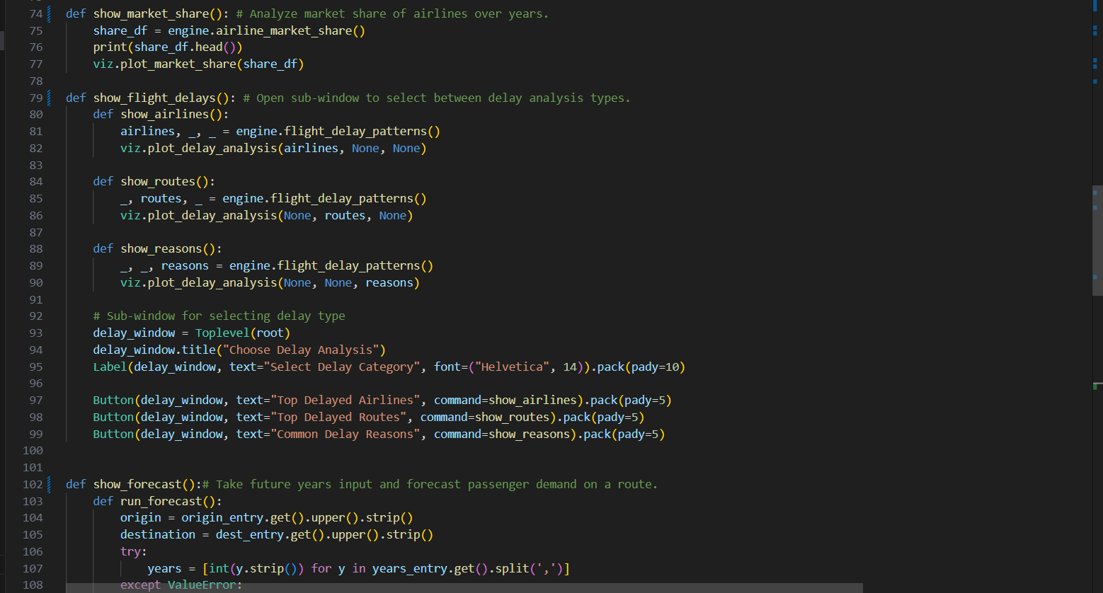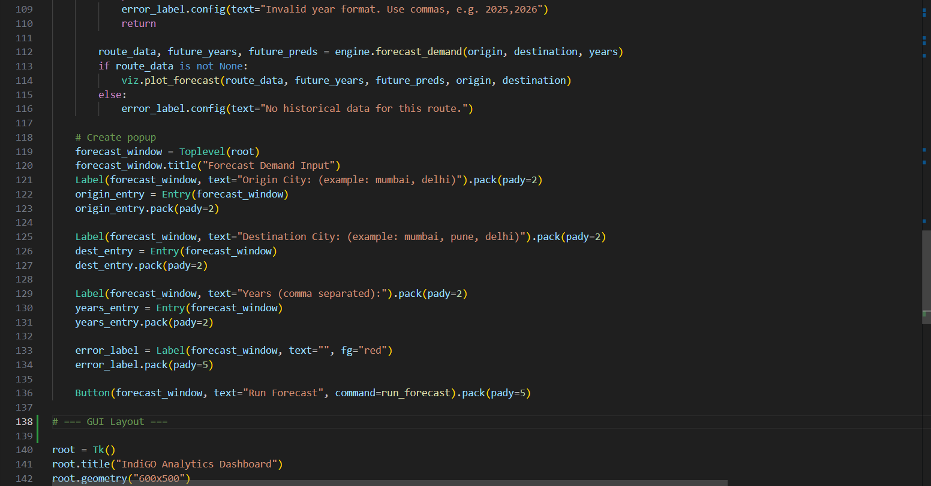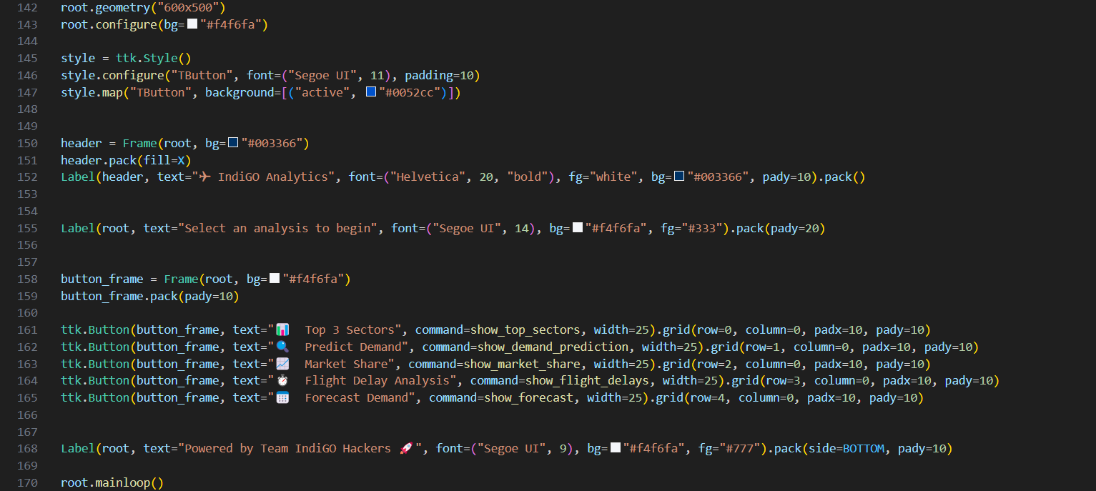

**Output Screenshots**

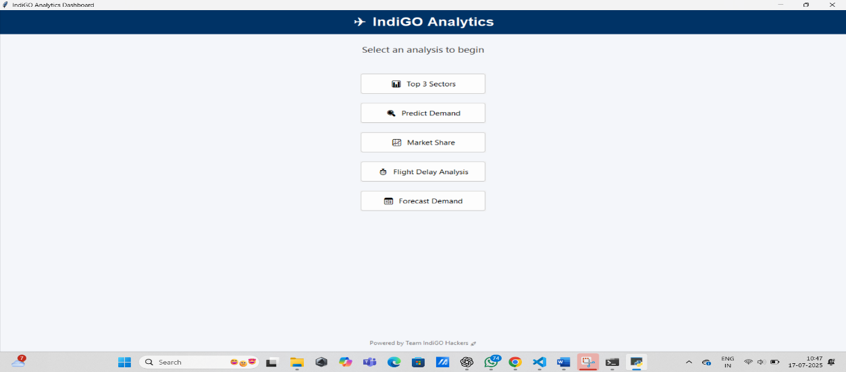

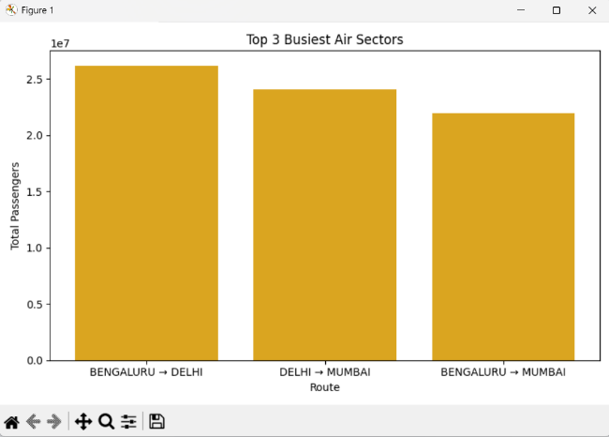 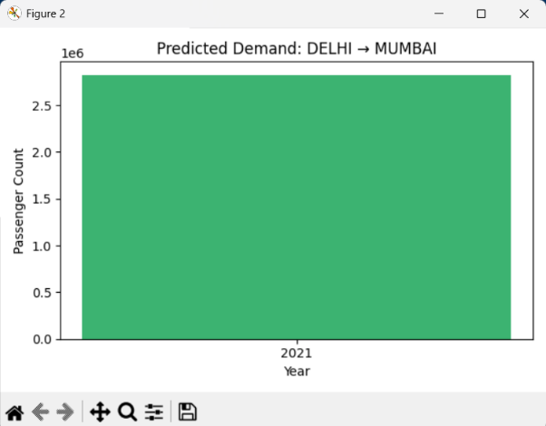

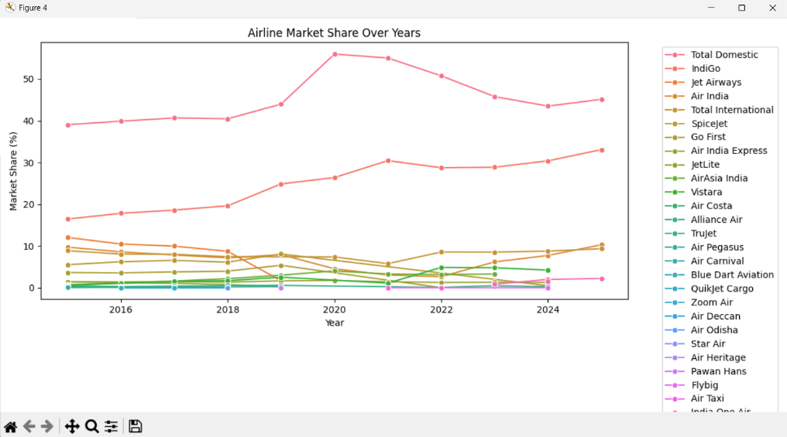

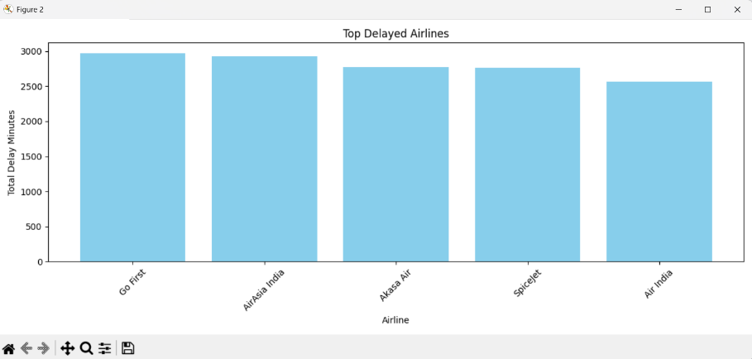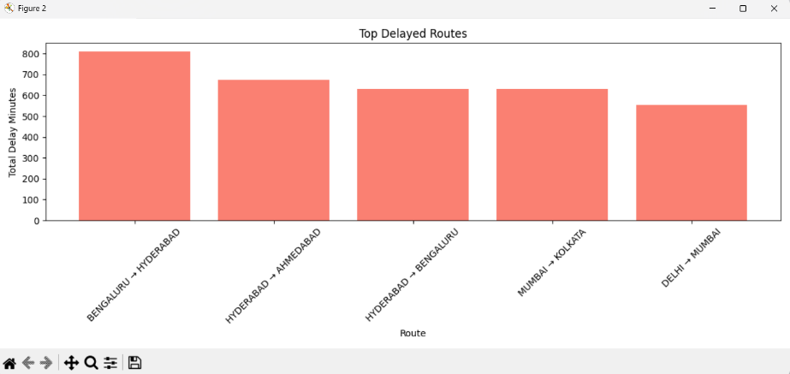

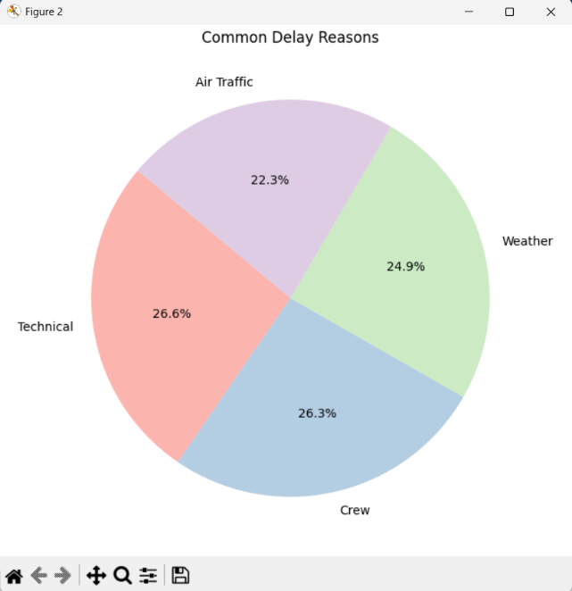

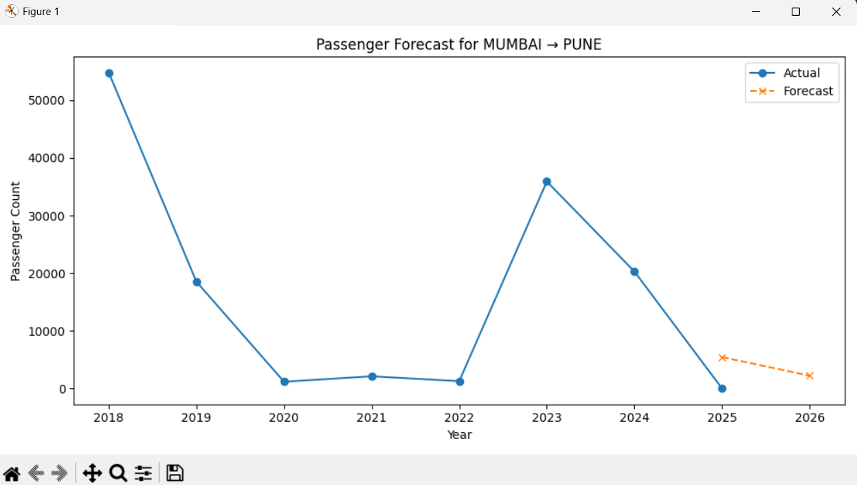

**Closure**

This project successfully bridges data science and aviation operations by analysing Indigo’s business strategy through an analytical lens. From identifying high-performing sectors to forecasting future demand and mapping market share trends, the application delivers valuable insights. The GUI enables easy access and interaction, making the tool practical for both academic and business use. Future enhancements include live data integration and advanced delay prediction models.

**Bibliography**

* DGCA Official Portal: <https://dgca.gov.in>
* Kaggle Aviation Datasets
* Python Docs: <https://docs.python.org>
* Matplotlib Docs: <https://matplotlib.org>
* Pandas Docs: https://pandas.pydata.org
* Seaborn Docs: https://seaborn.pydata.org
* Tkinter Docs: <https://docs.python.org/3/library/tkinter.html>